Name: Ronald Person
Theme: Temperature Converter pt2
GitHub Pages Link: https://github.com/RonaldJPerson/Project-103/tree/main/Assignment%203

Screenshot
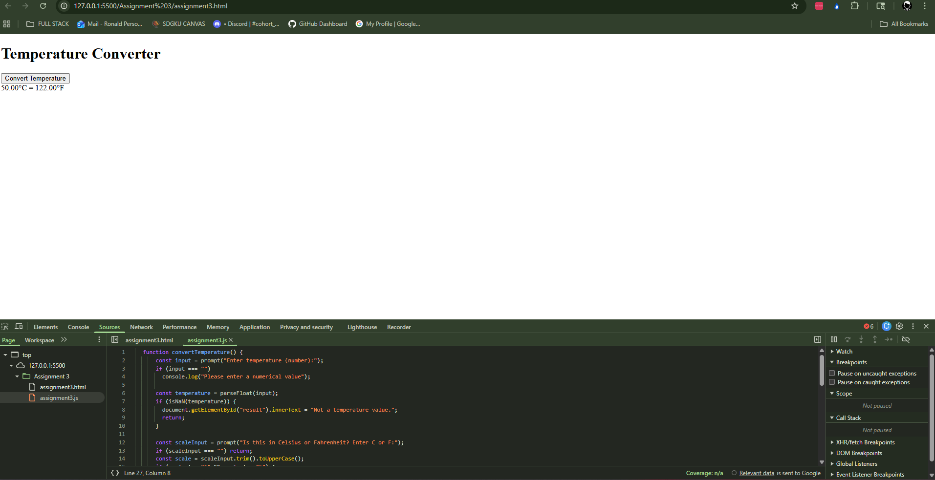

Summary of edits
- Create a function called convertTemperature.
- For the temperature, use an if statement to check the scale parameter. If it is "C", convert the temperature to Fahrenheit using the formula: Fahrenheit = (Celsius * 9/5) + 32. If it is "F", convert the temperature to Celsius using the formula: Celsius = (Fahrenheit - 32) * 5/9.
- Display the converted temperature on the HTML.

